CLOUD COMPUTING



SUBMITTED TO
ENGR. SHOAIB & SIR WAQAS SALEEM

SUBMITTED BY
HAMNA MAHMOOD
2023-BSE-025
BSE V-A

LAB 09
Codespaces + AWS: GH CLI (Codespaces), AWS CLI, EC2, IAM, Security Groups, Filters & Queries
Task 1 — GitHub CLI, Codespace setup and authentication
- (Local desktop) Install GitHub CLI:
task1_gh_install.png
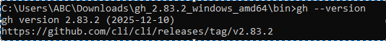
task1_gh_auth_login.png
- (Local) Authenticate GH CLI for Codespaces:
task1_gh_auth_login.png
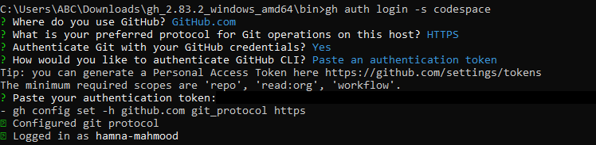
- (Local) List available Codespaces (optional verification):
task1_codespace_list.png
- (Local) Create or connect to a Codespace.
task1_codespace_ssh_connected.png

Task 2 — Install AWS CLI inside the Codespace and configure it
- Download and install AWS CLI:
task2_aws_install_and_version.png
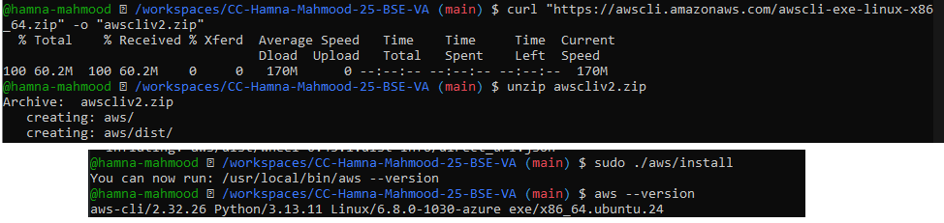
- Verify installation:
task2_aws_install_and_version.png
- Configure the AWS CLI (you will provide Access Key ID and Secret Access Key for a user with permissions, or use root/IAM user you prepared for the lab):
task2_aws_configure_and_files.png
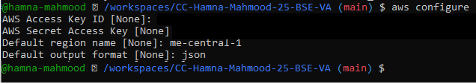
- Verify credentials/config files:
task2_aws_configure_and_files.png
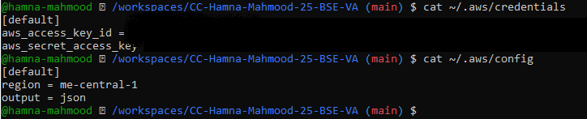
- Verify connectivity (you should see a JSON result showing your caller identity):
task2_aws_get_caller_identity.png
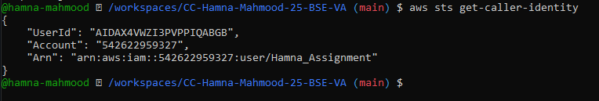
Task 3 — Create security group and add ingress rules using Codespace IP
- Create a security group (substitute your VPC id):
- task3_create_security_group_output.png
- 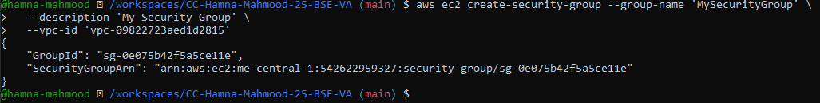
- Inspect the security group (initially ingress will be empty or default):
task3_describe_sg_before_ingress.png
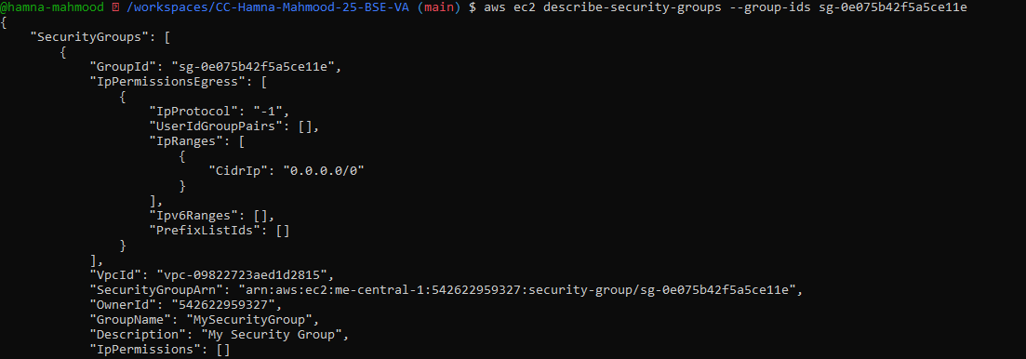
- Get your Codespace public IP (from inside the Codespace):
task3_codespace_public_ip.png
- Authorize SSH inbound on port 22 from your Codespace IP:
task3_authorize_ssh_and_describe.png
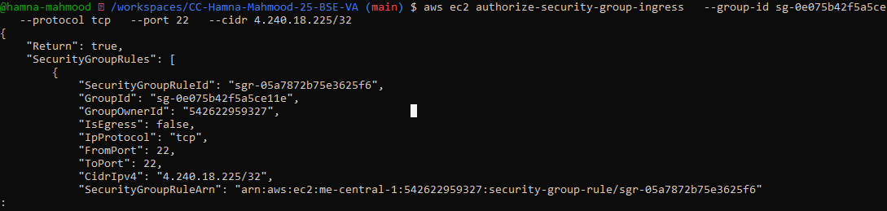
- Verify ingress rule appears:
task3_authorize_ssh_and_describe.png
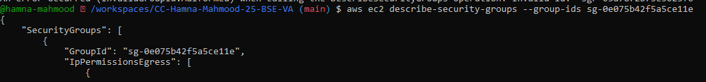
- Add an HTTP rule (port 80) using ip-permissions JSON:
task3_authorize_http_and_describe.png
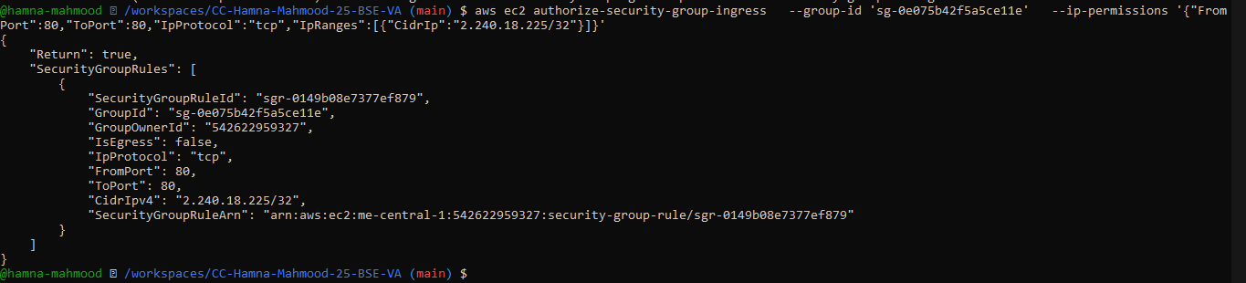
- Verify both ingress rules are present:
task3_describe_sg_final.png
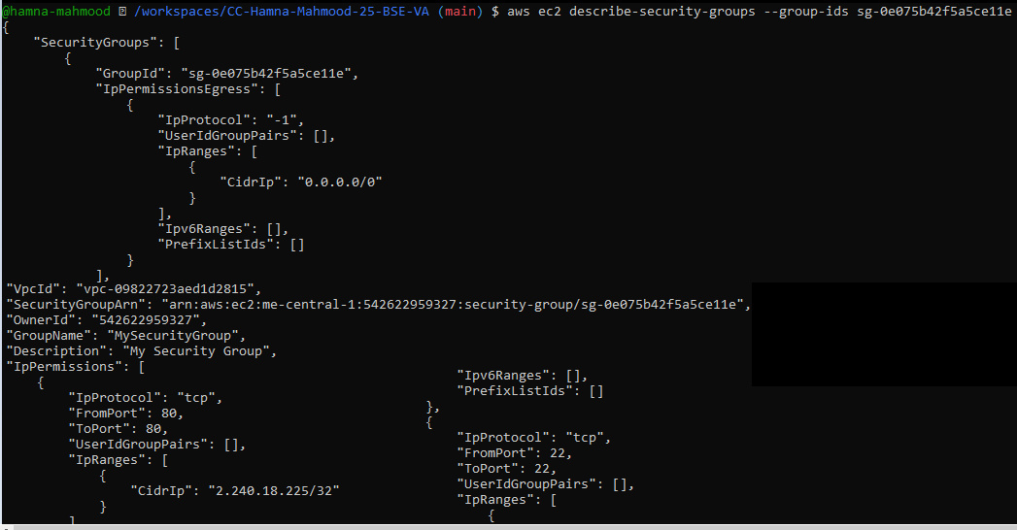
Task 4 — Create a key pair, describe key pairs, and launch EC2 instance
- Create the key pair and save the PEM file into the Codespace workspace:
task4_create_keypair_output.png
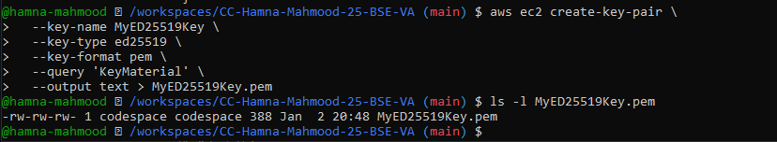
- View created key pairs:
task4_describe_keypairs.png
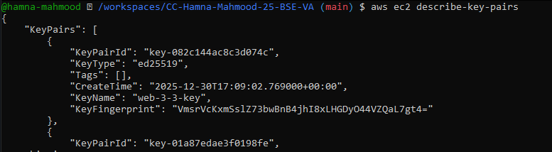
- Launch an EC2 instance (example values — replace IDs with ones from your account/region):
task4_run_instances_output.png
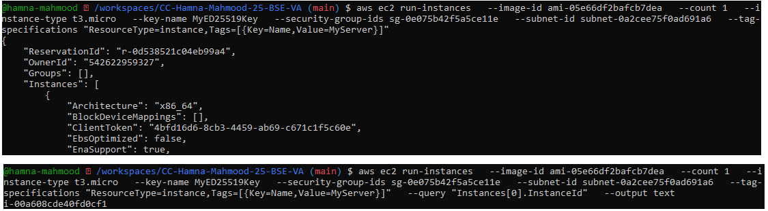
- Get the public IP address of your instance:
task4_describe_instances_public_ip.png
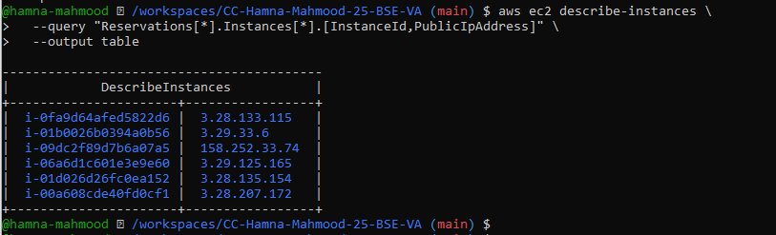
- Attempt SSH into the instance from the Codespace or from a machine whose IP is allowed in the security group:
task4_ssh_permission_error_and_fix.png
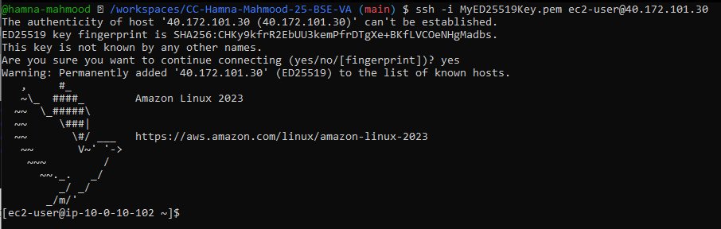
- Stop, start and (optionally) terminate the instance:
task4_stop_start_terminate_commands.png
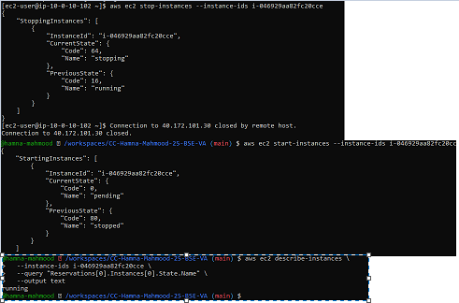
Task 5 — Understand AWS describe-* commands
Run and understand these commands (run each, then capture screenshot immediately after): task5_describe_security_groups.png
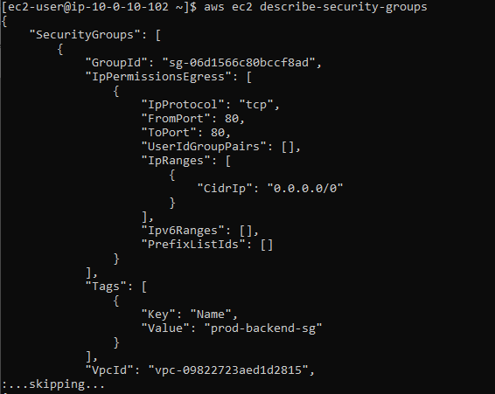
task5_describe_vpcs.png
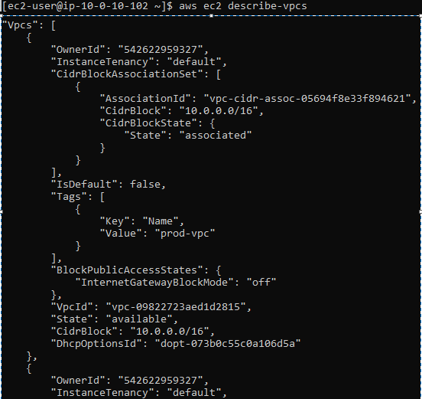
task5_describe_subnets.png
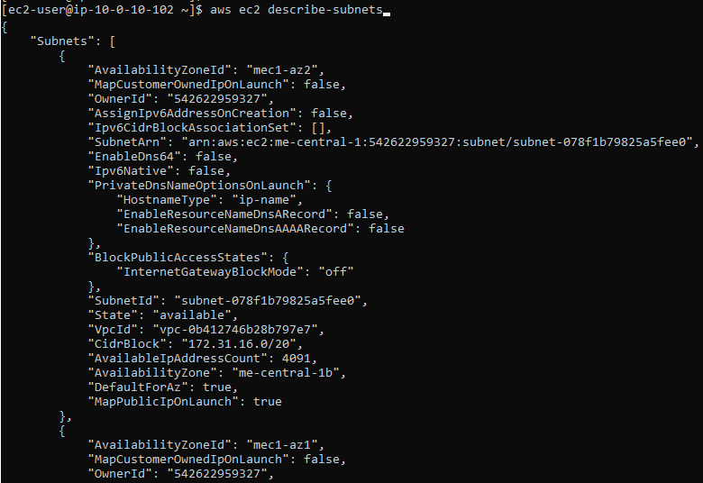
task5_describe_instances.png
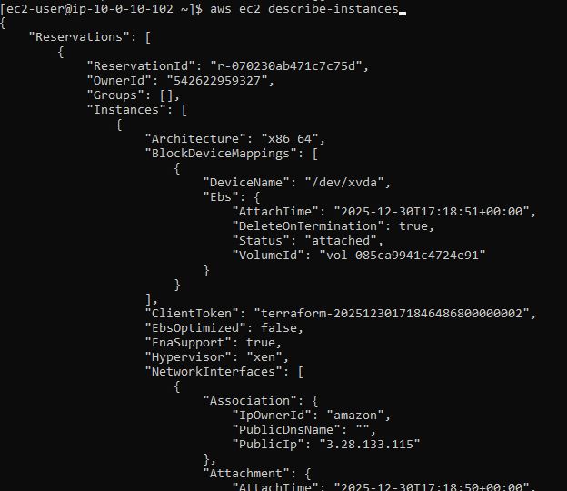

task5_describe_regions.png
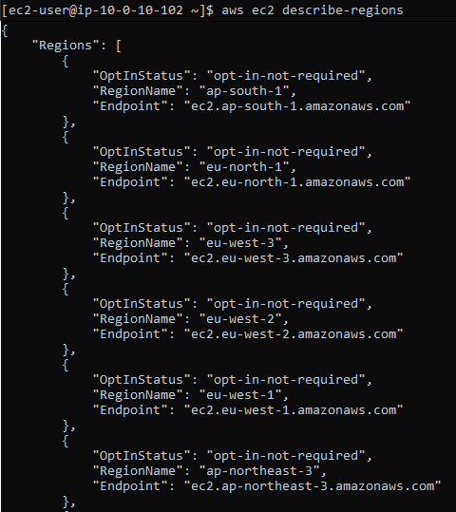
task5_describe_availability_zones.png
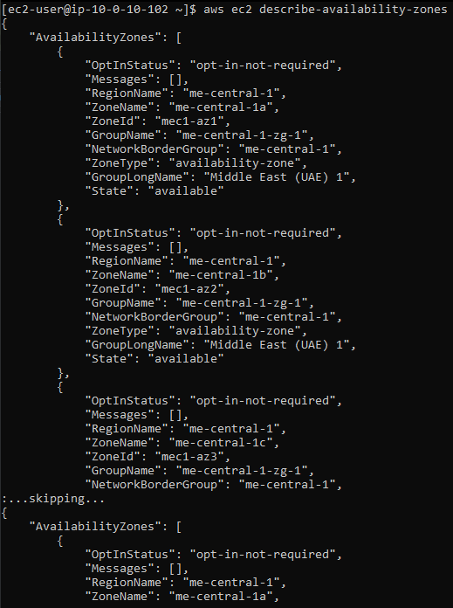
Task 6 — IAM: create group, user, attach policies, create console login & keys
Create group:
task6_create_group_and_user.png
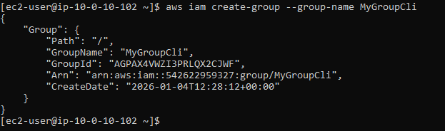
Get group details:
task6_create_group_and_user.png
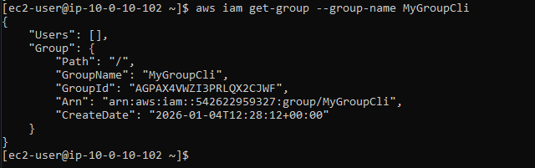
Create user:
task6_create_group_and_user.png
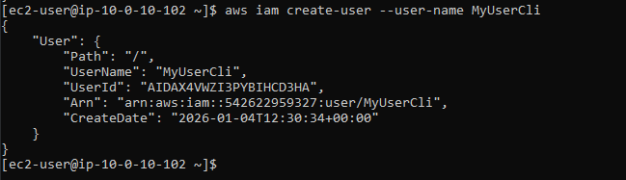
Get user details:
task6_create_group_and_user.png
Add user to group:
task6_add_user_to_group_and_verify.png
See group again:
task6_add_user_to_group_and_verify.png
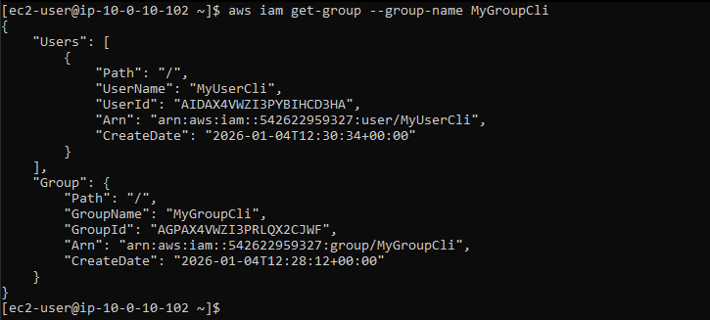
List policies that mention EC2:
task6_policy_list_and_attach.png
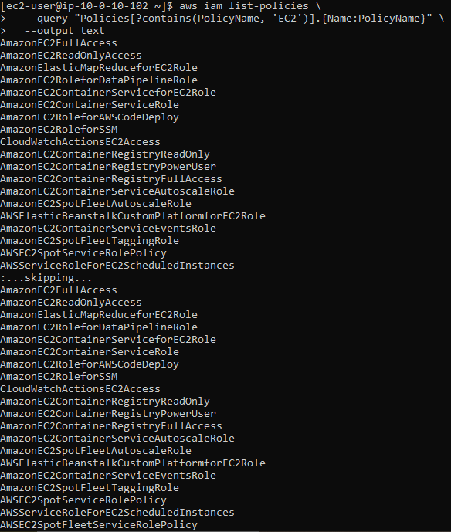
Get ARN for AmazonEC2FullAccess (example query):
task6_policy_list_and_attach.png
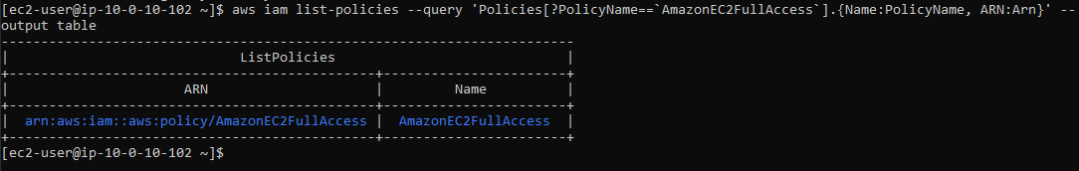
Attach policy to group (use the ARN you retrieved):
task6_policy_list_and_attach.png
List attached policies for the group:
task6_policy_list_and_attach.png
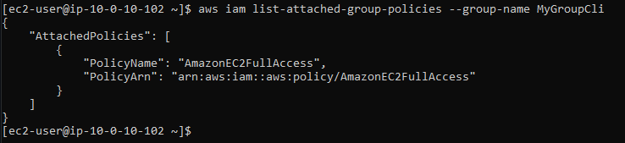
Create a console login profile for the user:
task6_create_login_profile_and_signin.png
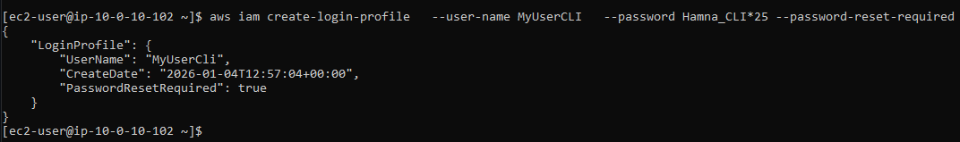
Create access keys for the user (save AccessKeyId and SecretAccessKey securely):
task6_create_access_key_output.png
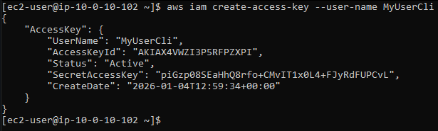
List access keys:
task6_create_access_key_output.png
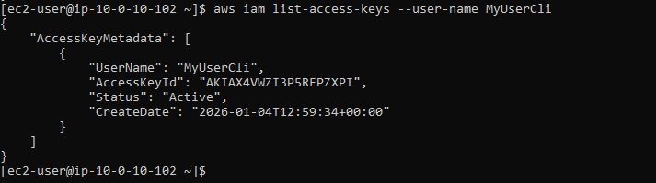
Use environment variables to authenticate as that user in the Codespace:
task6_env_exports_and_get_user_error.png
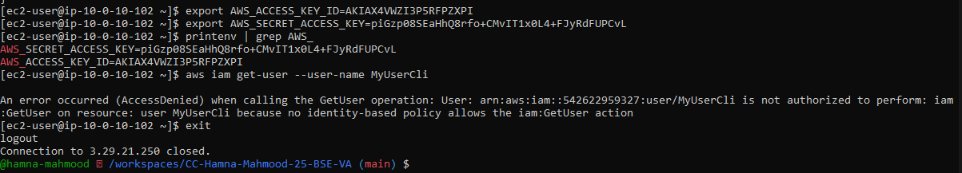
After clearing or switching credentials, repeat get-user and save:
task6_after_logout_get_user_success.png
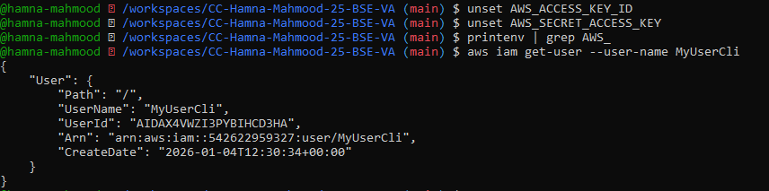

Task 7 — Filters: query with filters to find instances and their attributes
task7_filter_by_tag_public_ip.png
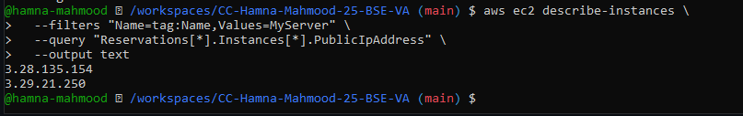
task7_filter_by_instance_type.png
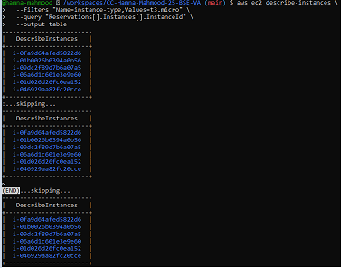
task7_filter_by_subnet.png
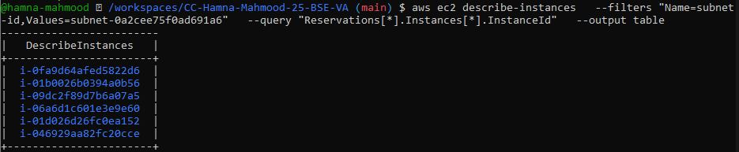
task7_filter_by_vpc.png
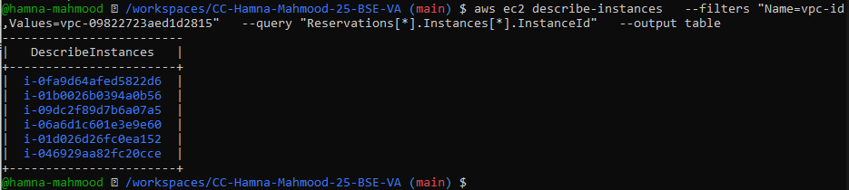

Task 8 — Use --query to format outputs for reporting
task8_query_table_instances_name_ip.png
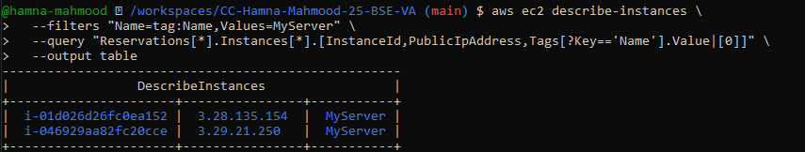
task8_query_table_instance_state.png
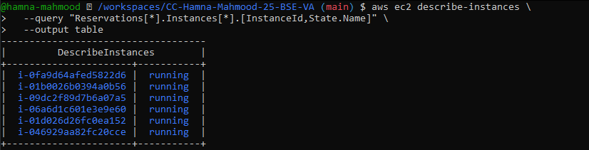
task8_query_table_instance_type_az.png
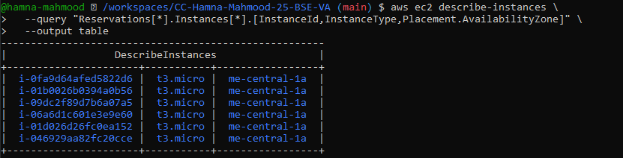

Cleanup — Remove resources to avoid charges
cleanup_terminate_instance.png
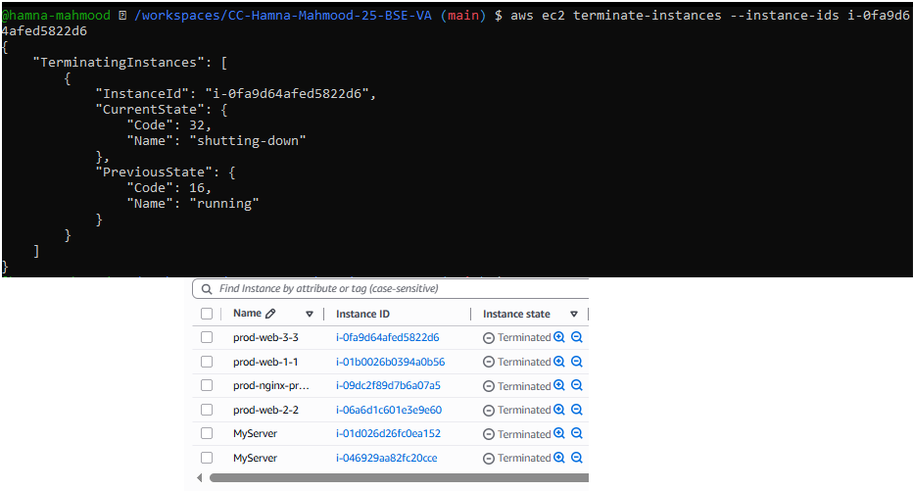
cleanup_delete_volumes_snapshots.png
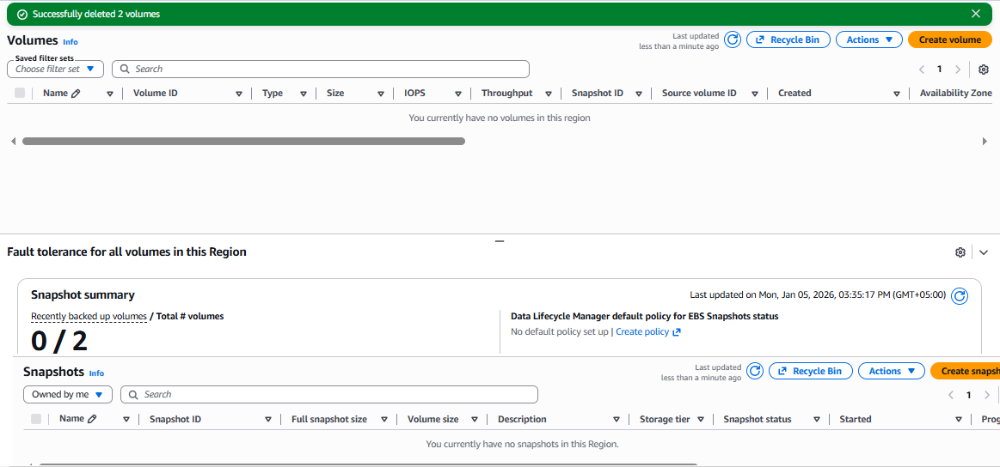

cleanup_delete_security_group_and_keypair.png
These groups cannot be deleted as they are default.
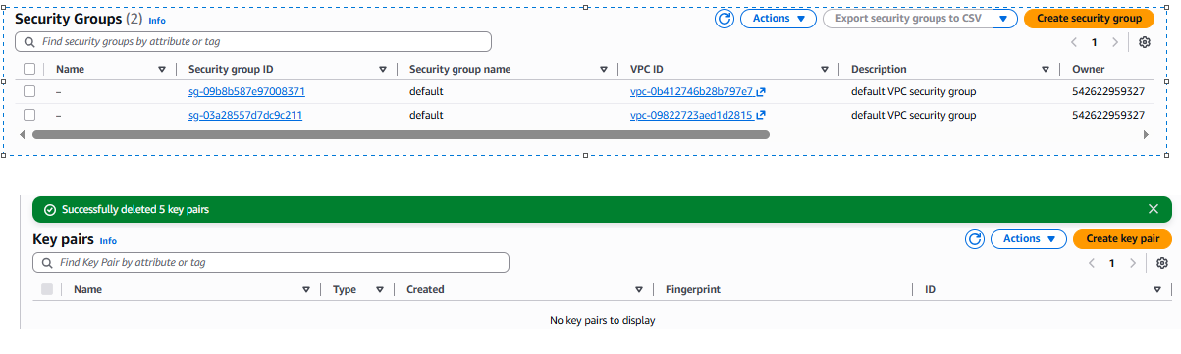
cleanup_iam_users_deleted.png
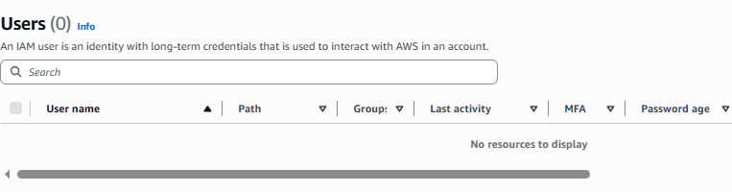
cleanup_summary.png
Only default security groups remain.
